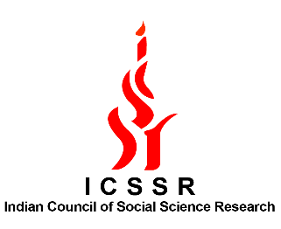

Indian Council of Social Science Research (ICSSR), New Delhi
&
National Science and Technology Council (NSTC), Taipei, Taiwan

JOINT CALL FOR RESEARCH PROPOSALS 2024

PRINCIPAL INVESTIGATOR INFORMATION
Last Name |  |  |  |  | First Name(s) |  |  |  | Date of birth
Name of Institution
Official Address
Phone |  |  |  |  |  |  | Email Address
Current Position / Title and name of department / school
From what institution did you receive your PhD? |  |  |  |  |  |  |  |  | Date
In what subject area?
If you have alternative equivalent qualifications to a PhD, please state what these are and when completed
Nationality |  |  |  |  |  | Passport Number

COUNTERPART PRINCIPAL INVESTIGATOR INFORMATION
Last Name |  |  |  | First Name(s) |  |  | Date of birth
Name of Institution
Official Address
Phone |  |  |  |  |  | Email Address
Current Position / Title and name of department / school
From what institution did you receive your PhD? |  |  |  |  |  |  | Date
In what subject area?

DETAILS OF THE AFFILIATING INSTITUTION
Name of Institution
Official Address
Phone |  |  |  | Email Address
Name of administrative contact (if available) |  |  | Position / Title
Name of head of department / institution

Project Title and Summary

Please include a project summary (limited to 200 words).

Curriculum Vitae

CVs of Indian Principal Investigator and Taiwanese Principal Investigator which include covering major qualifications, major research publications in the past five years and other related information material.

Project Description: joint research

Please include a description of the project and the intended outcomes (between 1000-1500 words).

Enclose a Separate Sheet wherever required

Budget:

Types of Expenses: | Amount (in Rupees)
Resources- Manpower
Travel costs (International and Domestic)
Workshop and Survey
Equipment
Publications
Contingency
Overheads Institutional Costs (7.5% of the total expenditure costs given)
Total Project Costs

Supporting documents with the application:

- Project proposal
- Letter of Affiliation
- CVs of the Indian and Taiwanese applicants

Applications must be submitted to (Contact Details):

ICSSR, New Delhi:
M.P.Madhukar, Deputy Director & In-charge, International Collaboration Programme, Indian Council of Social Science Research, Aruna Asaf Ali Marg, JNU Institutional Area, New Delhi – 110 067, Tel: ++ 91 (0) 11 - 26742832, Email: adinchargeics@gmail.com

Last Date for receiving applications is 1st May 2023.

